1. Create multiply, division, and subtraction functions with arrow function/fat arrow

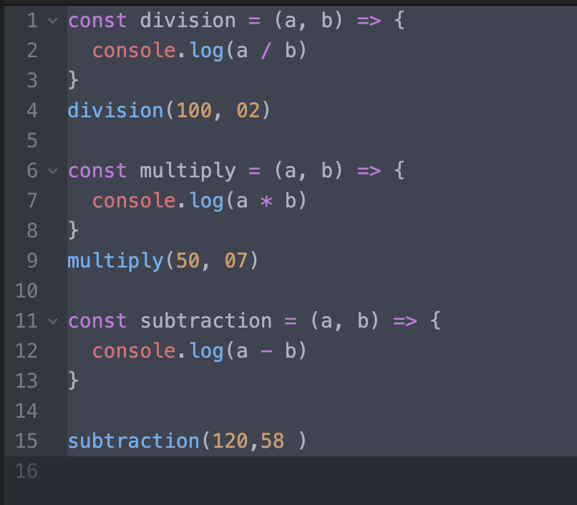

1. Create an employee object and display its data in the console (for...in).

1. Use Array helper functions
   1. Check if all the property values(firstName) in an array of object is same or not

array of object

[{

firstName: 'alina',

id: 1,

age: 14

}, {

firstName: 'harry',

id: 2,

age: 15

}, {

firstName: 'alex',

id: 3,

age: 16

}]

* 1. Get the value of the first element in an array that has value greater than 20

* 1. Get the value of the first element in an array that has value less than 20

* 1. Filter data based on an id(property) in an array of objects: pick any random id value

* 1. Round off all the decimal numbers in an array and sum all the values [9.8, 9.7, 4.5, 3.4]

* 1. Get all the person name based on age greater than and equal to 18, eligible to vote

[{

firstName: 'joe',

age: 24

}, {

firstName: 'alina',

age: 12

},

{

firstName: 'alex',

age: 20

}]

* 1. Sum all the elements of an array [90, 89, 56, 45]

* 1. Check element is odd or even in an array [90, 89, 56, 45]

* 1. Sum of all the salaries and display final sum value

[{

salary: 56000,

},

{

salary: 90000

}]

* 1. Concat all array elements ['red', 'pink', 'orange', 'red']: 'redpinkorangered'

